# PROJECT MANAGEMENT

# ĐẶC TẢ USE CASE

THÀNH VIÊN

Phan Thế Hùng – 1359013

Vũ Quang Nhật Huy – 1359054

Bùi Nguyễn Thiện Khánh – 1359041

Đặng Văn Long – 1359024

## Use case diagram

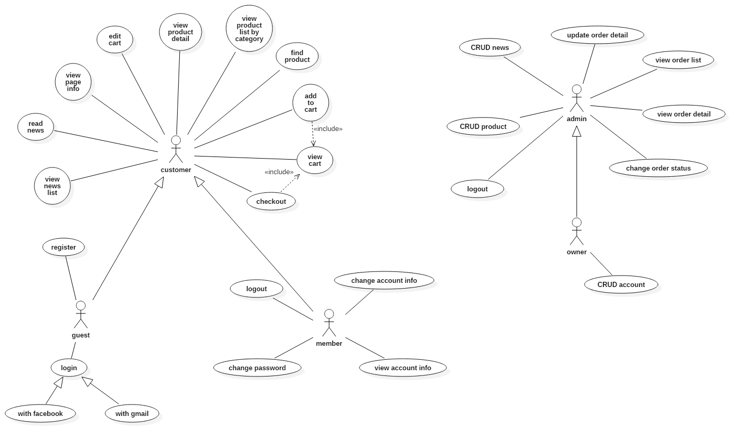

## Danh sách use case

|  |  |  |
| --- | --- | --- |
| **Use case ID** | **Name** | **Notes** |
| UCID-01 | login |  |
| UCID-02 | logout |  |
| UCID-03 | register |  |
| UCID-04 | find product |  |
| UCID-05 | view product detail | view product detail as customer |
| UCID-06 | view product list by category |  |
| UCID-07 | view info pages |  |
| UCID-08 | view news list |  |
| UCID-09 | read news | read news as customer |
| UCID-10 | view account information |  |
| UCID-11 | change account info |  |
| UCID-12 | change password |  |
| UCID-13 | add to cart |  |
| UCID-14 | view cart |  |
| UCID-15 | edit cart |  |
| UCID-16 | create product |  |
| UCID-17 | view product | view product detail as admin |
| UCID-18 | update product |  |
| UCID-19 | delete product |  |
| UCID-20 | create news |  |
| UCID-21 | view news | review news as admin |
| UCID-22 | update news |  |
| UCID-23 | delete news |  |
| UCID-24 | view order list |  |
| UCID-25 | view order detail |  |
| UCID-26 | change order status |  |
| UCID-27 | update order detail |  |
| UCID-28 | create account |  |
| UCID-29 | view account |  |
| UCID-30 | update account |  |
| UCID-31 | delete account |  |
| UCID-32 | change privilege |  |

## Đặc tả use case

|  |  |
| --- | --- |
| ***Use case ID*** | **UCID-01** |
| *Name* | Login |
| *Brief descriptions* | Member or admin can login to their account |
| *Main flow* | 1. User fill in username and password 2. Click login button 3. System validate information 4. System response to login request |
| *Alternative Flows* | 1. System validate information    1. Missing username or password    2. System ask user to fill in missing field |
| *Special requirements* | No |
| *Pre-conditions* | No |
| *Post-conditions* | No |
| *Additional notes* | No |

|  |  |
| --- | --- |
| ***Use case ID*** | **UCID-02** |
| *Name* | Logout |
| *Brief descriptions* | Member or admin logout their account |
| *Main flow* | 1. User click logout button |
| *Alternative Flows* | No |
| *Special requirements* | No |
| *Pre-conditions* | User has logged in to account |
| *Post-conditions* | No |
| *Additional notes* | No |

|  |  |
| --- | --- |
| ***Use case ID*** | **UCID-03** |
| *Name* | Register |
| *Brief descriptions* | A guest user register for an account |
| *Main flow* | 1. User fill in username , password, email, phone number 2. Click register button 3. System validate information 4. System response to request |
| *Alternative Flows* | 1. System validate information    1. Missing username or password    2. System ask user to fill in missing field |
| *Special requirements* | No |
| *Pre-conditions* | No |
| *Post-conditions* | No |
| *Additional notes* | No |

|  |  |
| --- | --- |
| ***Use case ID*** | **UCID-04** |
| *Name* | Find product |
| *Brief descriptions* | User can find product by name |
| *Main flow* | 1. User type the name of the product in search field 2. Click find button 3. Website show a list of products with the given name |
| *Alternative Flows* | No |
| *Special requirements* | No |
| *Pre-conditions* | No |
| *Post-conditions* | No |
| *Additional notes* | No |

|  |  |
| --- | --- |
| ***Use case ID*** | **UCID-05** |
| *Name* | View product detail |
| *Brief descriptions* | User view detail information of a product such as price, description, usage |
| *Main flow* | 1. User click on a product 2. Website show detail information of product |
| *Alternative Flows* | No |
| *Special requirements* | No |
| *Pre-conditions* | No |
| *Post-conditions* | No |
| *Additional notes* | No |

|  |  |
| --- | --- |
| ***Use case ID*** | **UCID-06** |
| *Name* | View product by category |
| *Brief descriptions* | User view a list of product of desired category |
| *Main flow* | 1. User click on the category 2. Website show a list of product of that category |
| *Alternative Flows* | No |
| *Special requirements* | No |
| *Pre-conditions* | No |
| *Post-conditions* | No |
| *Additional notes* | No |

|  |  |
| --- | --- |
| ***Use case ID*** | **UCID-07** |
| *Name* | View info page |
| *Brief descriptions* | User view information of the shop and owner |
| *Main flow* | 1. User click on piece of information he want to know 2. Website shows the desired information |
| *Alternative Flows* | No |
| *Special requirements* | No |
| *Pre-conditions* | No |
| *Post-conditions* | No |
| *Additional notes* | No |

|  |  |
| --- | --- |
| ***Use case ID*** | **UCID-08** |
| *Name* | View news list |
| *Brief descriptions* | User can view a list of news about matcha product |
| *Main flow* | 1. User click on news page 2. Website shows a list of news |
| *Alternative Flows* | No |
| *Special requirements* | No |
| *Pre-conditions* | No |
| *Post-conditions* | No |
| *Additional notes* | No |

|  |  |
| --- | --- |
| ***Use case ID*** | **UCID-09** |
| *Name* | Read news |
| *Brief descriptions* | User can read the desired piece of news |
| *Main flow* | 1. User click on the desired news 2. Website show the news |
| *Alternative Flows* | No |
| *Special requirements* | No |
| *Pre-conditions* | No |
| *Post-conditions* | No |
| *Additional notes* | No |

|  |  |
| --- | --- |
| ***Use case ID*** | **UCID-10** |
| *Name* | View account information |
| *Brief descriptions* | Member and admin can view their account information |
| *Main flow* | 1. User click on account tab 2. Website shows user account information |
| *Alternative Flows* | No |
| *Special requirements* | No |
| *Pre-conditions* | Account has been logged in |
| *Post-conditions* | No |
| *Additional notes* | No |

|  |  |
| --- | --- |
| ***Use case ID*** | **UCID-11** |
| *Name* | Change account info |
| *Brief descriptions* | Member and admin can change their account information |
| *Main flow* | 1. User click on change account info button 2. User change information in information field 3. Click change button 4. System announce success or fail |
| *Alternative Flows* | 1. System validate information    1. Missing username    2. System ask user to fill in missing field |
| *Special requirements* | No |
| *Pre-conditions* | No |
| *Post-conditions* | No |
| *Additional notes* | No |

|  |  |
| --- | --- |
| ***Use case ID*** | **UCID-12** |
| *Name* | Change password |
| *Brief descriptions* | Member and admin can change password of their account |
| *Main flow* | 1. User fill in old password once and news password twice 2. Click change button 3. System validate information 4. Website announce success or fail |
| *Alternative Flows* | 1. System validate information    1. User has not fill in one of password fields    2. System ask user to fill in missing field |
| *Special requirements* | No |
| *Pre-conditions* | No |
| *Post-conditions* | No |
| *Additional notes* | No |

|  |  |
| --- | --- |
| ***Use case ID*** | **UCID-13** |
| *Name* | Add to cart |
| *Brief descriptions* | User can add a product to online shopping cart |
| *Main flow* | 1. User choose product and click add to cart button 2. System redirect to view cart page |
| *Alternative Flows* | No |
| *Special requirements* | No |
| *Pre-conditions* | No |
| *Post-conditions* | No |
| *Additional notes* | No |

|  |  |
| --- | --- |
| ***Use case ID*** | **UCID-14** |
| *Name* | View cart |
| *Brief descriptions* | User can view a list of products that use has added to online shopping cart |
| *Main flow* | 1. User click on view cart button 2. System shows a list of product |
| *Alternative Flows* | No |
| *Special requirements* | No |
| *Pre-conditions* | No |
| *Post-conditions* | No |
| *Additional notes* | No |

|  |  |
| --- | --- |
| ***Use case ID*** | **UCID-15** |
| *Name* | Edit cart |
| *Brief descriptions* | User can change the number of product or remove a product from online shopping cart |
| *Main flow* | 1. User change the amount of a desired product 2. System refresh and make the change to cart |
| *Alternative Flows* | No |
| *Special requirements* | No |
| *Pre-conditions* | No |
| *Post-conditions* | No |
| *Additional notes* | No |

|  |  |
| --- | --- |
| ***Use case ID*** | **UCID-16** |
| *Name* | Create product |
| *Brief descriptions* | Admin can add a to product list |
| *Main flow* | 1. User fill in product information fields 2. Click create 3. System validate information 4. System announce success or fail |
| *Alternative Flows* | 1. System validate information    1. Missing information       1. System ask user to fill in the missing field |
| *Special requirements* | No |
| *Pre-conditions* | User has logged in as admin |
| *Post-conditions* | No |
| *Additional notes* | No |

|  |  |
| --- | --- |
| ***Use case ID*** | **UCID-17** |
| *Name* | View product |
| *Brief descriptions* | User can view detail information of product |
| *Main flow* | 1. User click on desired product 2. System show detail information of chosen product |
| *Alternative Flows* | No |
| *Special requirements* | No |
| *Pre-conditions* | User has logged in as admin |
| *Post-conditions* | No |
| *Additional notes* | No |

|  |  |
| --- | --- |
| ***Use case ID*** | **UCID-18** |
| *Name* | Update product |
| *Brief descriptions* | User can update information of a product |
| *Main flow* | 1. User change information of a product in information fields 2. User click change 3. System validate information 4. System announce success or fail |
| *Alternative Flows* | 1. System validate information    1. Missing information       1. System ask user to fill in missing field |
| *Special requirements* | No |
| *Pre-conditions* | User has logged in as admin |
| *Post-conditions* | No |
| *Additional notes* | No |

|  |  |
| --- | --- |
| ***Use case ID*** | **UCID-19** |
| *Name* | Delete product |
| *Brief descriptions* | User can remove a product from product list |
| *Main flow* | 1. User choose a product and click delete button 2. System announce success or fail |
| *Alternative Flows* | No |
| *Special requirements* | No |
| *Pre-conditions* | User has logged in as admin |
| *Post-conditions* | No |
| *Additional notes* | No |

|  |  |
| --- | --- |
| ***Use case ID*** | **UCID-20** |
| *Name* | Create news |
| *Brief descriptions* | Admin can add a to news list |
| *Main flow* | 1. User fill in news information fields 2. Click create 3. System validate information 4. System announce success or fail |
| *Alternative Flows* | 1. System validate information    1. Missing information       1. System ask user to fill in the missing field |
| *Special requirements* | No |
| *Pre-conditions* | User has logged in as admin |
| *Post-conditions* | No |
| *Additional notes* | No |

|  |  |
| --- | --- |
| ***Use case ID*** | **UCID-21** |
| *Name* | View news |
| *Brief descriptions* | User can view detail information of news |
| *Main flow* | 1. User click on desired news 2. System show detail information of chosen news |
| *Alternative Flows* | No |
| *Special requirements* | No |
| *Pre-conditions* | User has logged in as admin |
| *Post-conditions* | No |
| *Additional notes* | No |

|  |  |
| --- | --- |
| ***Use case ID*** | **UCID-22** |
| *Name* | Update news |
| *Brief descriptions* | User can update information of a news |
| *Main flow* | 1. User change information of a news in information fields 2. User click change 3. System validate information 4. System announce success or fail |
| *Alternative Flows* | 1. System validate information    1. Missing information       1. System ask user to fill in missing field |
| *Special requirements* | No |
| *Pre-conditions* | User has logged in as admin |
| *Post-conditions* | No |
| *Additional notes* | No |

|  |  |
| --- | --- |
| ***Use case ID*** | **UCID-23** |
| *Name* | Delete news |
| *Brief descriptions* | User can remove a news from news list |
| *Main flow* | 1. User choose a news and click delete button 2. System announce success or fail |
| *Alternative Flows* | No |
| *Special requirements* | No |
| *Pre-conditions* | User has logged in as admin |
| *Post-conditions* | No |
| *Additional notes* | No |

|  |  |
| --- | --- |
| ***Use case ID*** | **UCID-24** |
| *Name* | View order list |
| *Brief descriptions* | Admin can view list of orders by status |
| *Main flow* | 1. User click on the type of order they want 2. System show list of orders with desired status |
| *Alternative Flows* | No |
| *Special requirements* | No |
| *Pre-conditions* | User has logged in as admin |
| *Post-conditions* | No |
| *Additional notes* | No |

|  |  |
| --- | --- |
| ***Use case ID*** | **UCID-25** |
| *Name* | View order detail |
| *Brief descriptions* | User can view detail information of order |
| *Main flow* | 1. User click on desired order 2. System show detail information of chosen order |
| *Alternative Flows* | No |
| *Special requirements* | No |
| *Pre-conditions* | User has logged in as admin |
| *Post-conditions* | No |
| *Additional notes* | No |

|  |  |
| --- | --- |
| ***Use case ID*** | **UCID-26** |
| *Name* | change order status |
| *Brief descriptions* | User can change status of an order |
| *Main flow* | 1. User choose an order and change status to new, processing or delivered 2. System announce success or fail |
| *Alternative Flows* | No |
| *Special requirements* | No |
| *Pre-conditions* | User has logged in as admin |
| *Post-conditions* | No |
| *Additional notes* | No |

|  |  |
| --- | --- |
| ***Use case ID*** | **UCID-27** |
| *Name* | Update order detail |
| *Brief descriptions* | User can remove a product within order |
| *Main flow* | 1. User choose a order and click detail button 2. System show list of product within order 3. User choose a product he want to remove and click delete button 4. System announce success or fail |
| *Alternative Flows* | No |
| *Special requirements* | No |
| *Pre-conditions* | User has logged in as admin |
| *Post-conditions* | No |
| *Additional notes* | No |

|  |  |
| --- | --- |
| ***Use case ID*** | **UCID-28** |
| *Name* | Create account |
| *Brief descriptions* | User can add a to account list |
| *Main flow* | 1. User fill in account information fields 2. Click create 3. System validate information 4. System announce success or fail |
| *Alternative Flows* | 1. System validate information    1. Missing information       1. System ask user to fill in the missing field |
| *Special requirements* | No |
| *Pre-conditions* | User has logged in as owner |
| *Post-conditions* | No |
| *Additional notes* | No |

|  |  |
| --- | --- |
| ***Use case ID*** | **UCID-29** |
| *Name* | View account |
| *Brief descriptions* | User can view detail information of account |
| *Main flow* | 1. User click on desired account 2. System show detail information of chosen account |
| *Alternative Flows* | No |
| *Special requirements* | No |
| *Pre-conditions* | User has logged in as owner |
| *Post-conditions* | No |
| *Additional notes* | No |

|  |  |
| --- | --- |
| ***Use case ID*** | **UCID-30** |
| *Name* | Update account |
| *Brief descriptions* | User can update information of an account |
| *Main flow* | 1. User change information of a account in information fields 2. User click change 3. System validate information 4. System announce success or fail |
| *Alternative Flows* | 1. System validate information    1. Missing information       1. System ask user to fill in missing field |
| *Special requirements* | No |
| *Pre-conditions* | User has logged in as owner |
| *Post-conditions* | No |
| *Additional notes* | No |

|  |  |
| --- | --- |
| ***Use case ID*** | **UCID-31** |
| *Name* | Delete account |
| *Brief descriptions* | User can remove an account from account list |
| *Main flow* | 1. User choose a account and click delete button 2. System announce success or fail |
| *Alternative Flows* | No |
| *Special requirements* | No |
| *Pre-conditions* | User has logged in as owner |
| *Post-conditions* | No |
| *Additional notes* | No |

|  |  |
| --- | --- |
| ***Use case ID*** | **UCID-32** |
| *Name* | Change privilege |
| *Brief descriptions* | User can change privilege right of an account |
| *Main flow* | 1. User choose a account and mark the a list of privileges which are granted to an account 2. User click save 3. System change the account’s privilege 4. System announce success or fail |
| *Alternative Flows* | No |
| *Special requirements* | No |
| *Pre-conditions* | User has logged in as owner |
| *Post-conditions* | No |
| *Additional notes* | No |